**Git Commands:** [**https://www.atlassian.com/git/glossary**](https://www.atlassian.com/git/glossary)

Config:

git config --global user.name "Your Name"

git config --global user.email [your.email@example.com](mailto:your.email@example.com)

git config --list

Add – to add files to stage area.

git add <file>

git add <directory>

git add .

🡪 to remove file from stage area

git restore --staged <exact_file_path_and_name>. (U can use remove command also -- git rm --cached src/remove.java.)

after adding to stage area but you don’t some file/folder to commit then use this command to remove from staged area

Commit: -- to save changes in local repo

git commit

it will open text editor to take long commit message then close it

git commit -m “meaning full commit message.”

git commit --amend

This will open new text editor to take commit message

git commit --amend -m “commit message”

Recommend: git commit --amend -m “sorry forget to add this changes in previous commit so replace previous commit instead of creating new commit”

Not recommend shortcut: git commit -am “added remaining files”

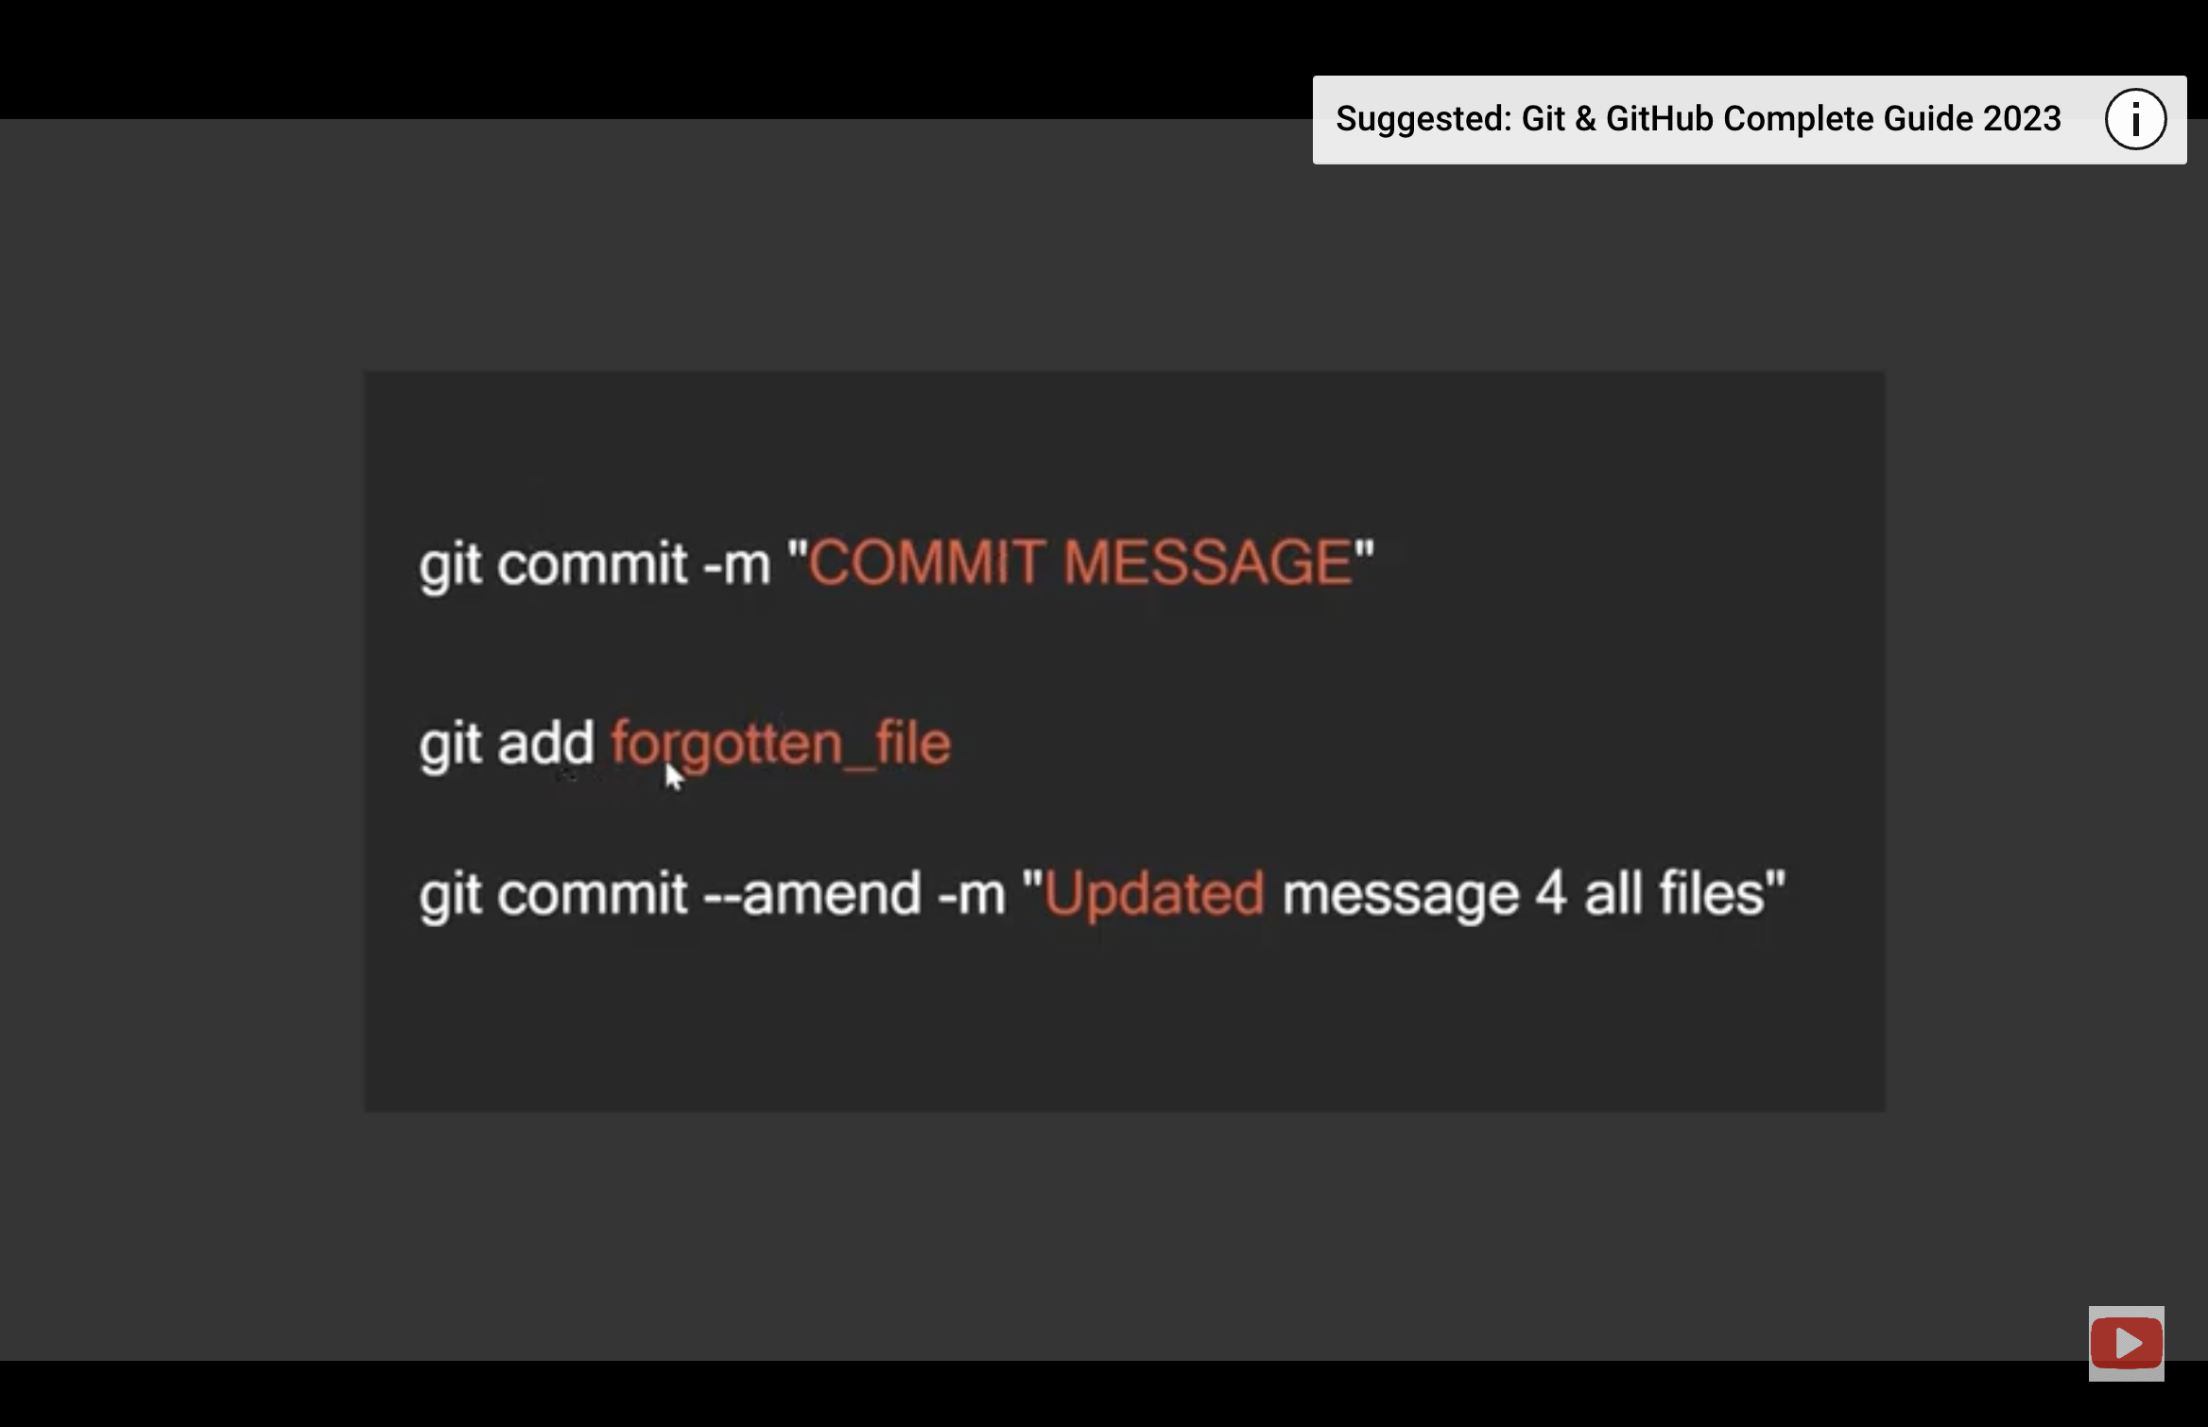

Branch:

git branch --list

List all the branches in your local repository

git branch -a

List all remote branches.

git branch <branch_name> – default source branch_name is master

git branch <branch_name> <source_or_base_branch_name>

Create a new branch called ＜branch＞ in local repo. This does not check out the new branch.

git branch -d <branch>

Delete the specified branch. This is a “safe” operation in that Git prevents you from deleting the branch if it has unmerged changes.

git branch -D <branch>

Force delete the specified branch, even if it has unmerged changes. This is the command to use if you want to permanently throw away all of the commits associated with a particular line of development.

git branch -m <branch>

Rename the current branch to ＜branch＞

git checkout ＜new-branch＞

enter into specific branch from current branch

git checkout -b ＜new-branch＞

create new branch and entered into created branch.

git checkout <commit-id>

checkout to specific git commit.

Checkout to remote branch:

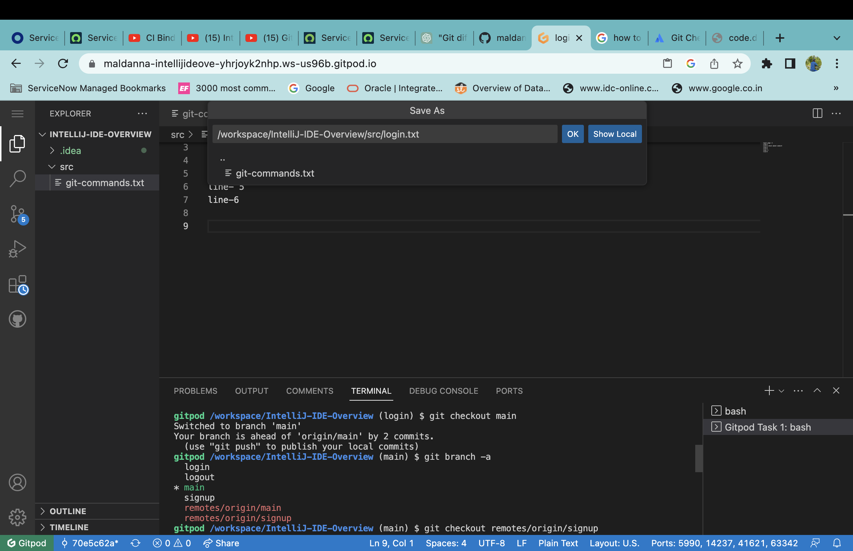

git checkout -b <new-branch-name> <existing-branch-name>

creating new branch from existing branch

diff -d Vs -D

if branch already merged then use

git branch -d <branch-name>

if branch not merged but still if you want delete branch then use below command

git branch -D <branch-name>

**Remote:**

git push origin --delete <remote_branch_name>

delete remote branch after merge to main or if you don’t want that specific branch changes then delete that branch.

git clone <repo link>

to get remote repository into local machine

**History:**

git log

it will show all commits in current branch.

git log --oneline

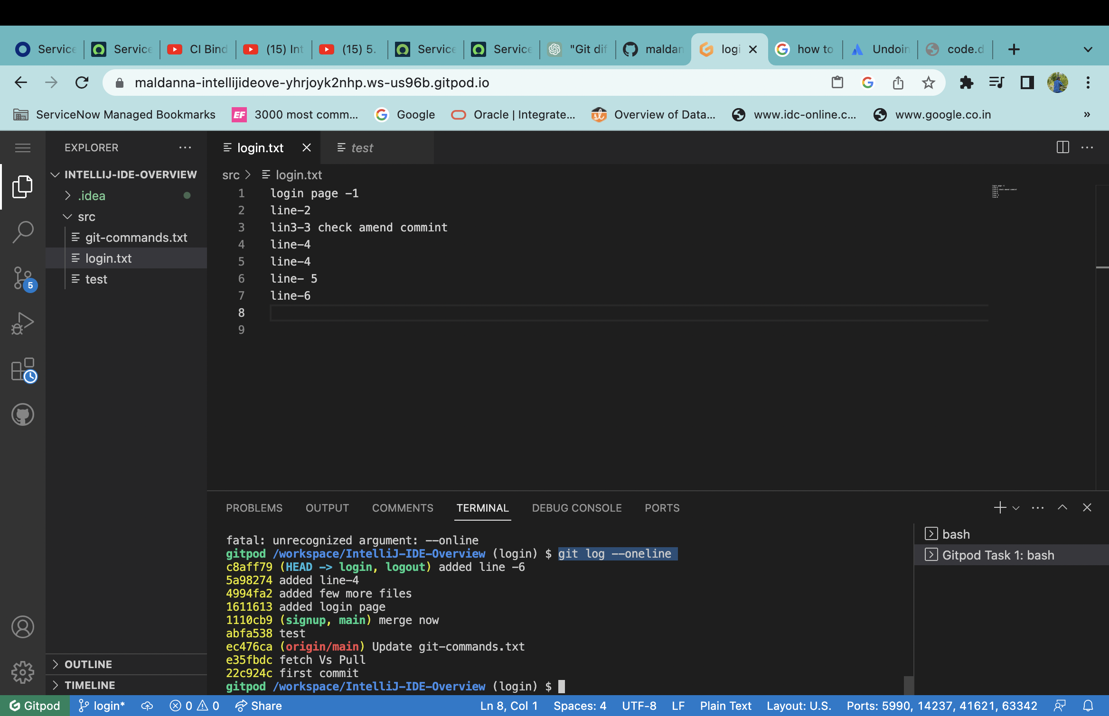

git log --branches=*

it will show all commits on all branches

**Undo**

git revert <commit_id>

before revert

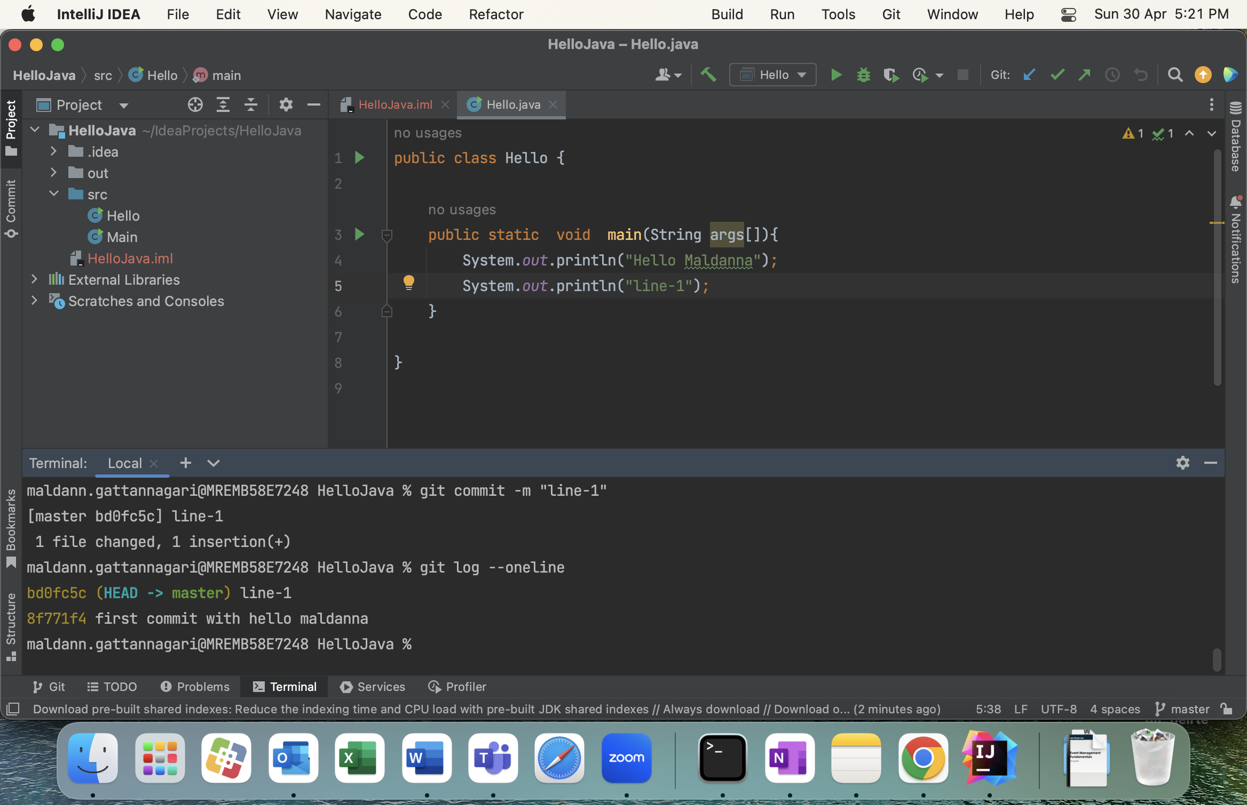

After revert:

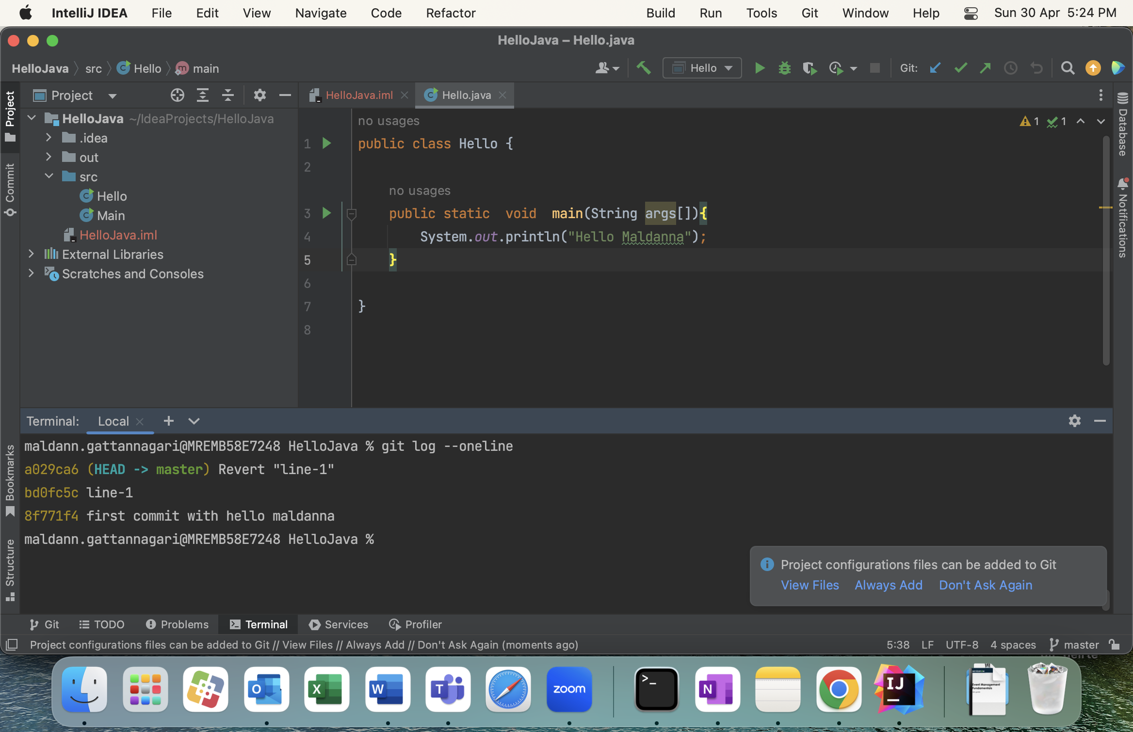

Link: <https://www.youtube.com/watch?v=hA3vYDyaZQQ>

If you want that changes again then revert on previous revert command

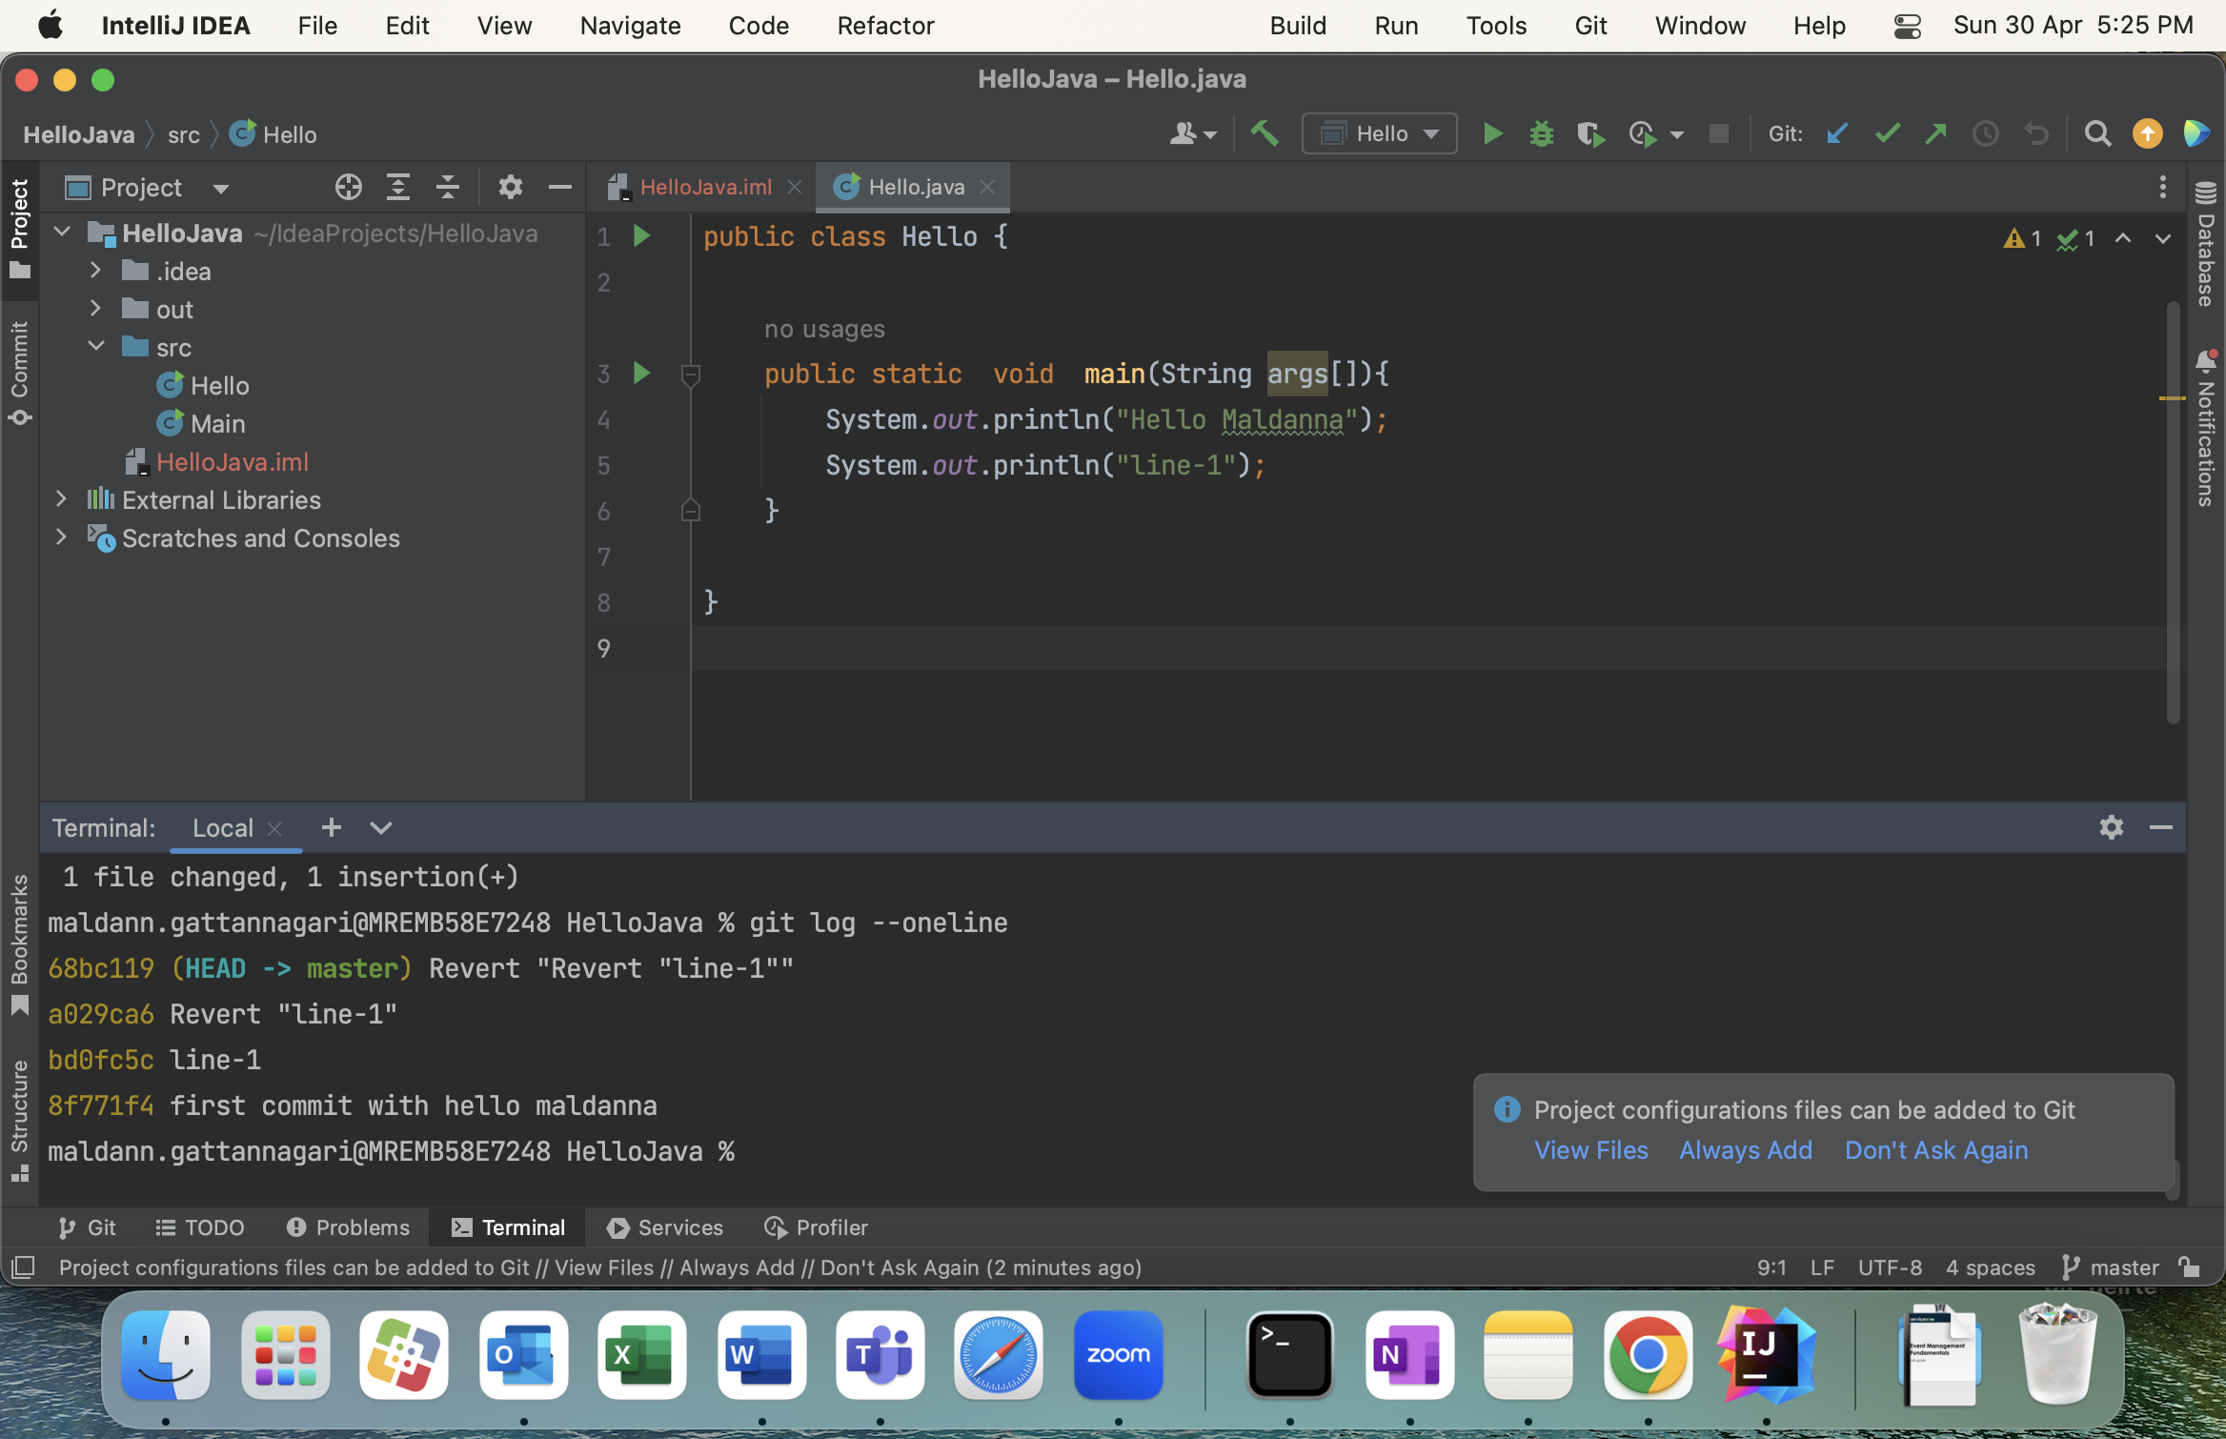

git reset <commit-id> ( not recommend – use revert command for undo changes)

before run:

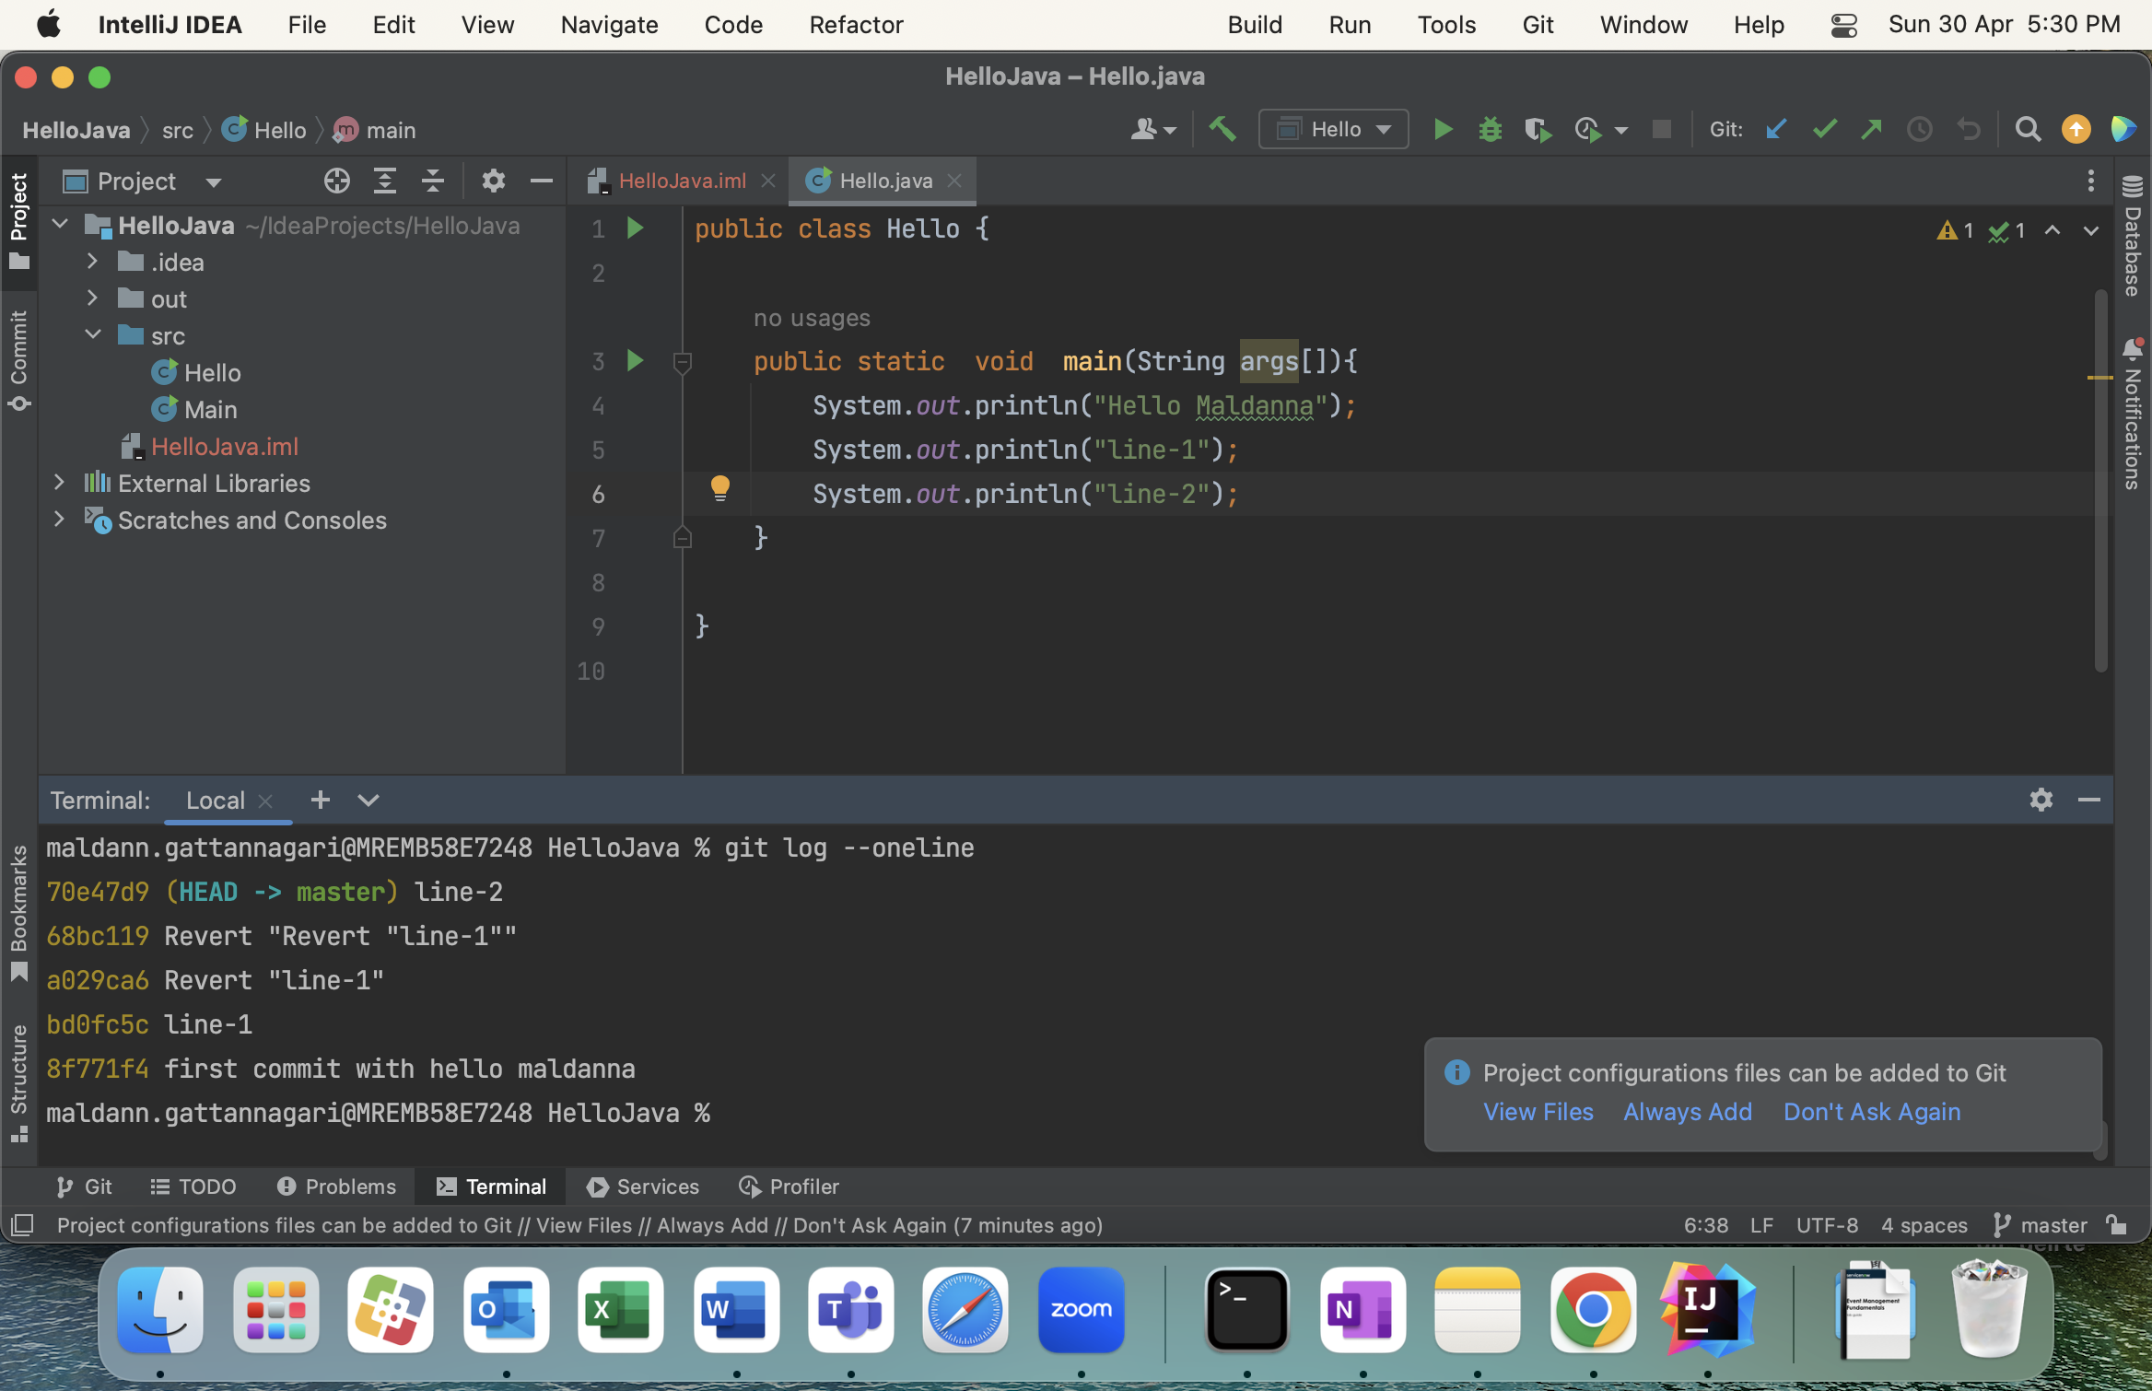

See All files in different area:

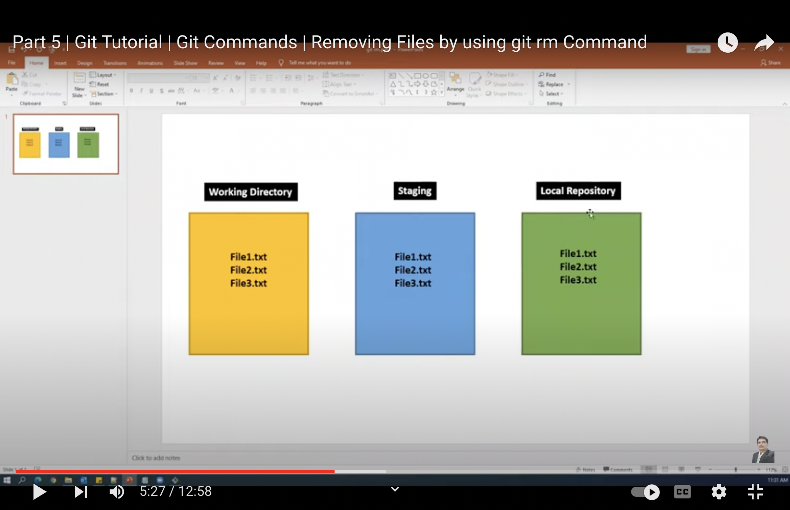

To see in current working directory -- Command – ls

To see all files in stage area -- Command – git ls-files

Remove file:

1. git rm <file_name>. --- if you want remove file from both working directory and staging area
2. git rm -r . – to remove all files from both areas
3. git rm --cached <file_name>. – to remove file from staging area (U can use unstage command also)
4. rm <file-name> -- to remove file from working directory

Complex Commands:

Merge

Merge login_feature(source) branch into master (target)

Step1: checkout to target branch. – git checkout master

Step2: git merge <source-branch> -- git merge login-feature

Rebase (similar to merge but small change): -

<https://www.atlassian.com/git/tutorials/rewriting-history/git-rebase>

Rebasing is the process of moving or combining a sequence of commits to a new base commit.

Merge lot of commits into single commit –

Step1: checkout to master

Step2: git rebase <branch-name>

Step3: resolve conflict

Step4: commit on master

Diff : <https://www.youtube.com/watch?v=f1wnYdLEpgI>

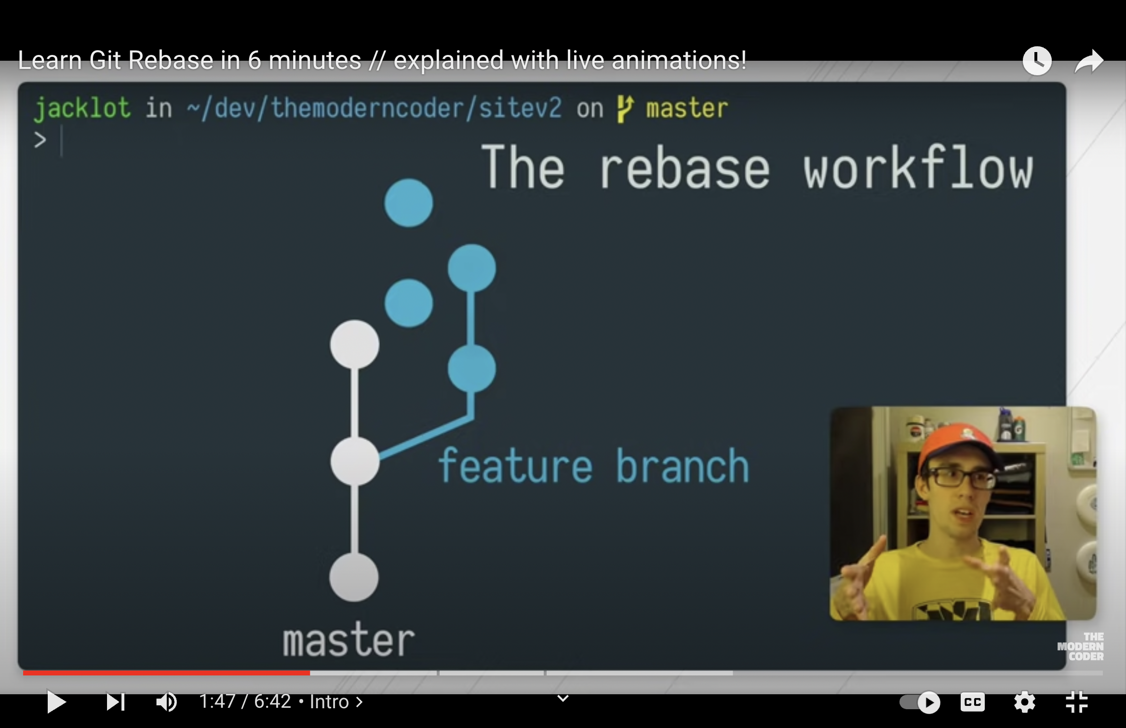

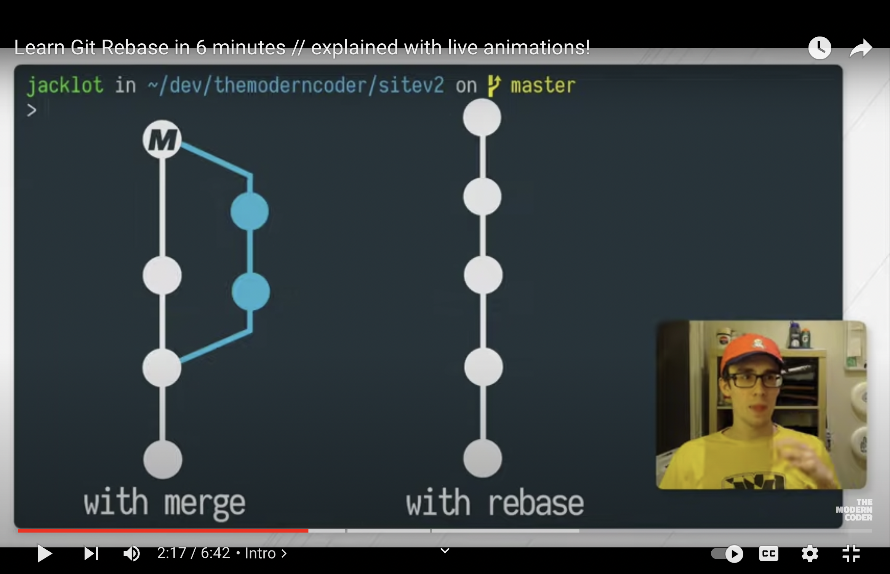

PULL (fetch + merge)

git pull <remote> <branch-name>

1. git clone
2. create login branch
3. checkout to to login
4. make modification’
5. commit in login
6. checkout to main
7. pull from remote to make upto date
8. resolve merge conflicts.
9. Merge from login into main’
10. Resolve conflicts
11. Commit in main
12. Push to origin

git pull - pulling from remote main to local main.

pull into specific branch:

step1: checkout into specific branch

step2: git pull <remote> <branch-name>

presteps:

git remote -v

git remote

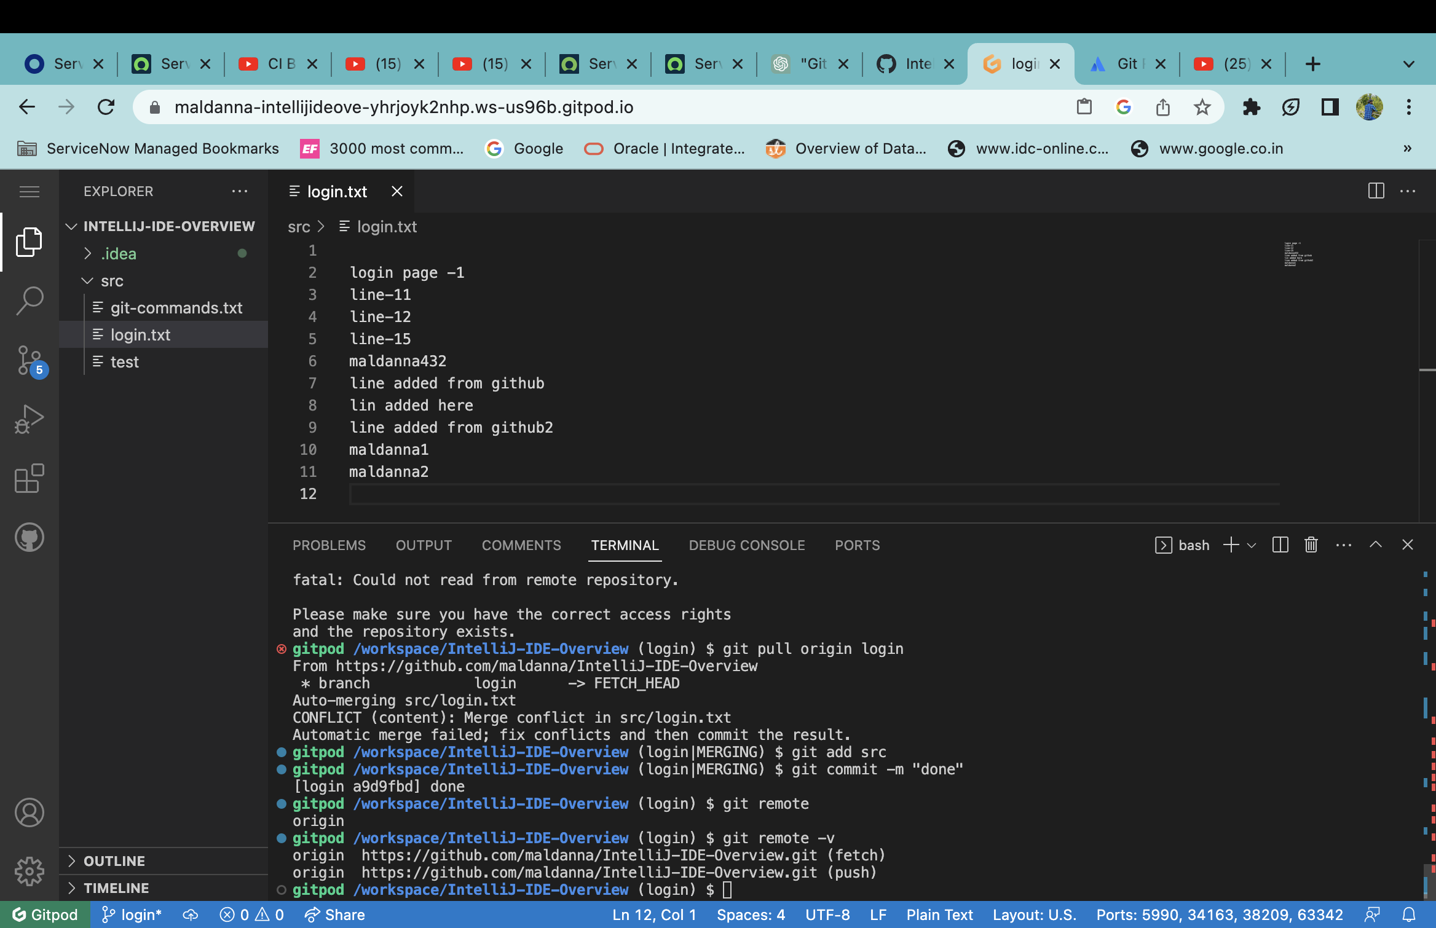

Git pull from remote main to local branch.

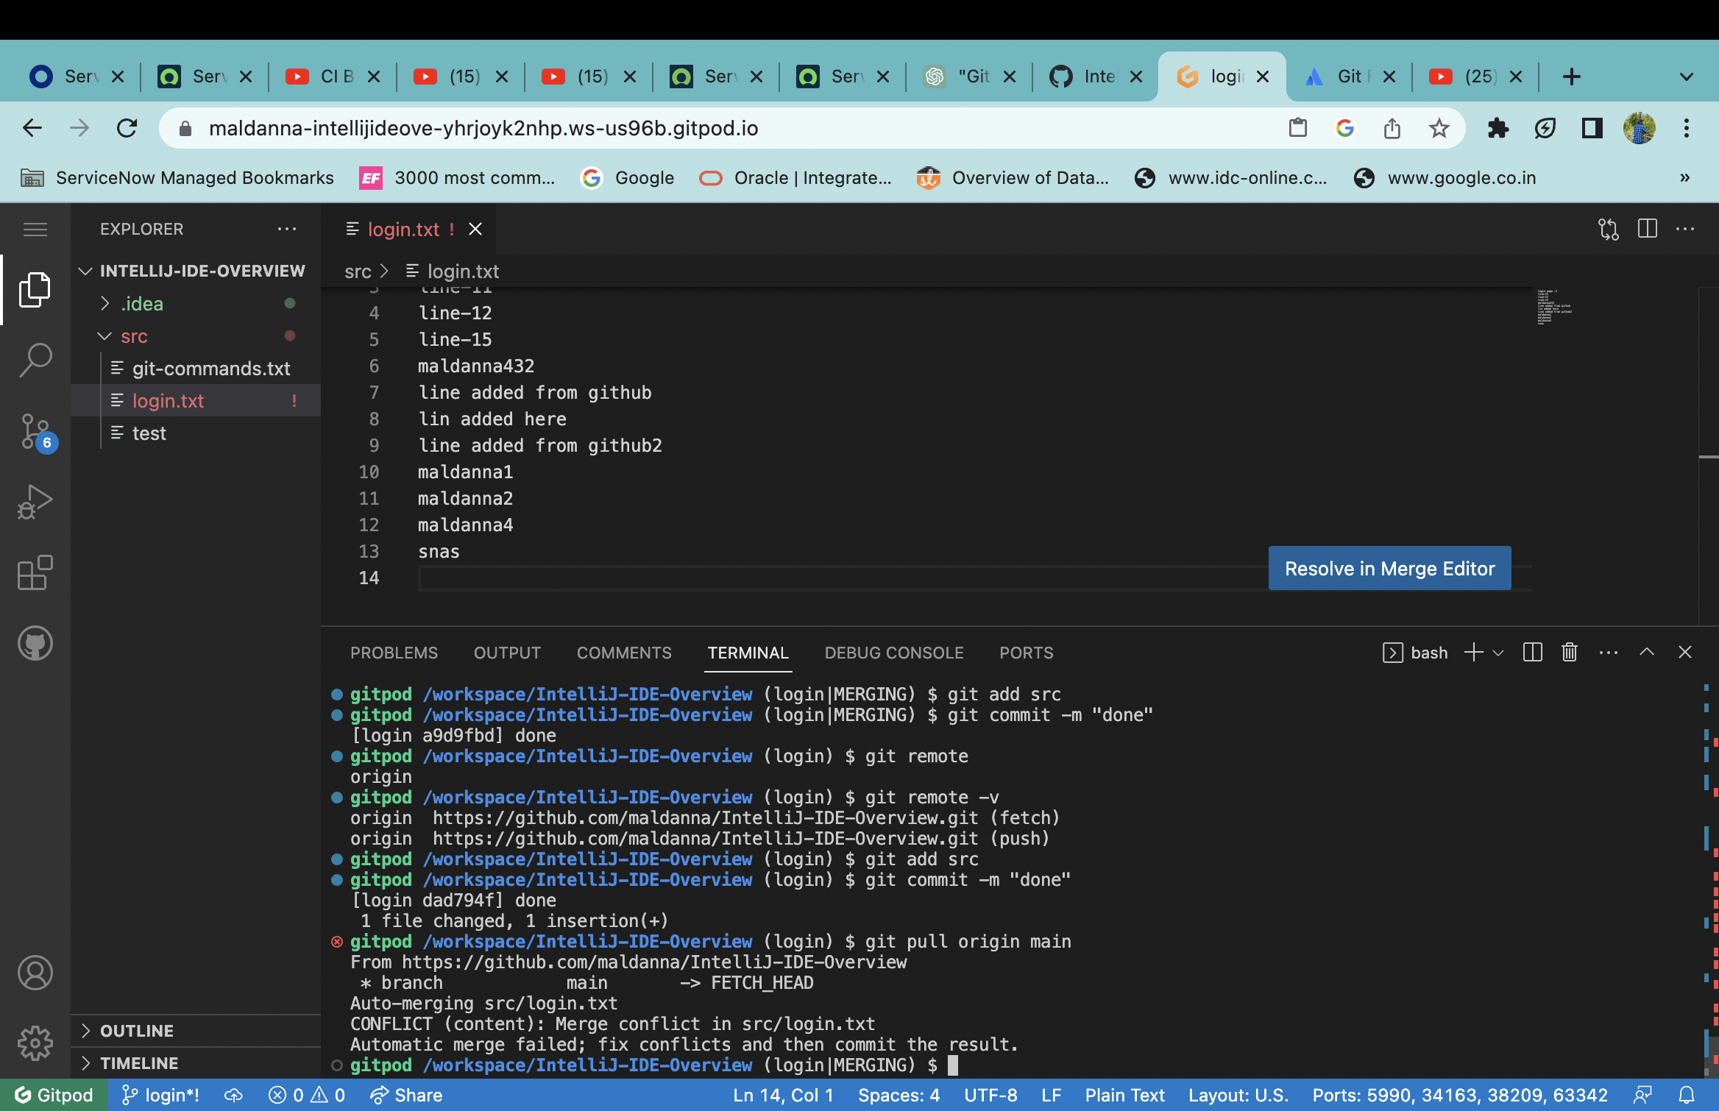

PUSH: git push <remote> <branch-name>

1. From local main to remote main

Step1: checkout to main

Step2: git pull.

Step3: resolve conflicts.

Step4: commit

Step5: git push

1. From local branch to remote branch

Step: checkout to that brach

Step2: do modifications

Step3: git pull from main or specific branch.

Step4: resolve conflicts.

Step5: push to specific branch

Like git push origin login

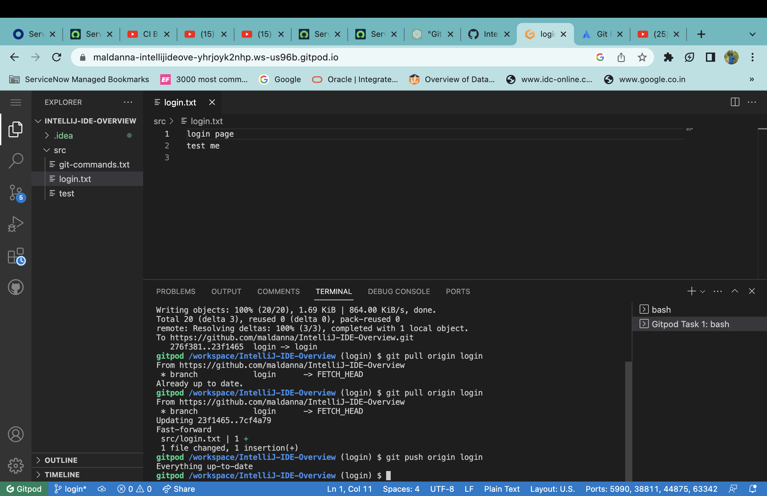

**Fetch:**

git fetch <remote> <branch-name>

step1: git fetch origin login 🡪 it will retrieve code from remote repo keep in u r local machine, but it won’t show in

